% Based on B30p121a.doc (figures for analysis paper)
% Preparing a probability density plot w/ error bars:

>>load P:\matlab12\larry\data\b27p129h.dat -mat % Loads the dwell time data
% To form a pdf histogram we define the boundaries (edges) of the
% histogram bins:
>>Edges=[0 1 2 3 4 5 6 7 10 13 16 19 22 27 32 37 47 57 67 77 127 177 477 877]+.5;
% We will plot the pdf histogram with x coordinates at the bin centers
>>Centers=[.5 1.5 2.5 3.5 4.5 5.5 6.5 8.5 11.5 14.5 17.5 20.5 24.5 29.5 34.5 42 52 62 72 102 152 327 677];
% Obtain the number of events N in each bin
>>N=histc(dwell488(:,5),Edges)
% The standard deviation uncertainty for the number of events in each bin
% is expressed as std = sqrt( p*q*Ntot), where
% p=(probability of events being in this bin) = (# in the bin)/Ntot
% Ntot = total number of landing events, and q = (1-p)
% These expressions are derived based on a binary distribution (‘binary’
% in the sense of each event either falls either (1) into the bin under
% consideration, or (2) outside the bin under consideration
% We therefore express the uncertainties in the number of events in each
% bin using:
>>uncertN=sqrt(1000*N(1:23)/1000.*(1-N(1:23)/1000)); % number N uncertainty in
% each of our bins

N | uncert
272 | 14.07
210 | 12.88
109 | 9.85
84 | 8.77
43 | 6.41
33 | 5.65
29 | 5.31
44 | 6.49
35 | 5.81
19 | 4.32
8 | 2.82
8 | 2.82
9 | 2.99
8 | 2.82
6 | 2.44
8 | 2.82
14 | 3.72
10 | 3.15
6 | 2.44
17 | 4.09
13 | 3.58
13 | 3.58
2 | 1.41
% Need to normalize both the event number and its uncertainty by the bin width
% and by the total event number (1000). We list the bin widths from above:

>>Widths=[ 1 1 1 1 1 1 1 3 3 3 3 3 5 5 5 10 10 10 10 50 50 300 400];

% Need to take care in forming the error bars on a log plot. You want the difference :
% upper error bar length = log(N+uncertainty) – log(N) = log( (N+uncertainty)/N) )
% lower error bar length = log(N) – log(N-uncertainty) = log( (N)/(N-uncertainty) )
% NOTE: multiplying both ‘N’ and ‘uncertainty’ by some normalization factor K
% does nothing to the length of the error bars on a log plot (just a ratio, so factor cancels).
% e.g.
% upper error bar length =log(N*K+uncertainty*K) – log(N*K)
=log(N+uncertainty) – log(N)
=log( (N+uncertainty)/N) )

>>log_uncertN_norm_Upper=log( (N(1:23)'+uncertN').*Widths.^(-1)/1000)-log( (N(1:23)').*Widths.^(-1)/1000)

>>log_uncertN_norm_Lower=log( (N(1:23)').*Widths.^(-1)/1000)-log( (N(1:23)'-uncertN').*Widths.^(-1)/1000)

% Now we plot the normalized pdf (normalized so that it integrates
% to 1). As implied by the above, we are plotting the natural log
% of the pdf here to emphasize the bi-exponential nature of
% the distribution

% Plot data with tmin time offset (tmin = 0.5 s)
>>figure(31);errorbar(Centers+.5, log(N(1:23)'.*Widths.^(-1)/1000),
log(N(1:23).*(N(1:23)-uncertN).^(-1)), log((N(1:23)+uncertN).*(N(1:23)).^(-1)),'x');shg

% Plot model pdf atop data
% Note that our data pdf integrates to 1: we plot the data using a
% distribution that normalizes to 1 so we see the probabilities
% associated with our observations. However the model
% includes events (at short times) that are missed by our data.
% Therefore, the model pdf expression integrates to a number
% somewhat higher than 1.
% Let me know if any of the variables or numbers in the following
% expression do not make sense: the expression is close (but not
% exactly the same) to what you used previously with the
% survival plots (it includes the background contribution in
% the model.

>>plot(tym, log((NbTb488-NbTbcntrl)/NbTb488* 1.1539*( (0.8521/2.9659)*exp(-tym/2.9659)+ (0.1479/62.1772)*exp(-tym/62.1772)) +NbTbcntrl/NbTb488*1.4304*((0.9632/1.34)*exp(-tym/1.34)+(.0368/420.56)*exp(-tym/420.56))),'k');
%NbTb488=binding frequency of data
%NbTbcntrl=binding frequency of control
%1.1539=Correction factor for data
%0.8521=data A
%2.9659=data tau1
%0.1479=1-data A
%62.1772=data tau2
%tym=0:2271 ie (want to cover duration of plot)
%1.4304=Correction factor for bk
%0.9632=bk A
%1.34=bk tau1
%0.0368=1-bk A
%420.56=bk tau2

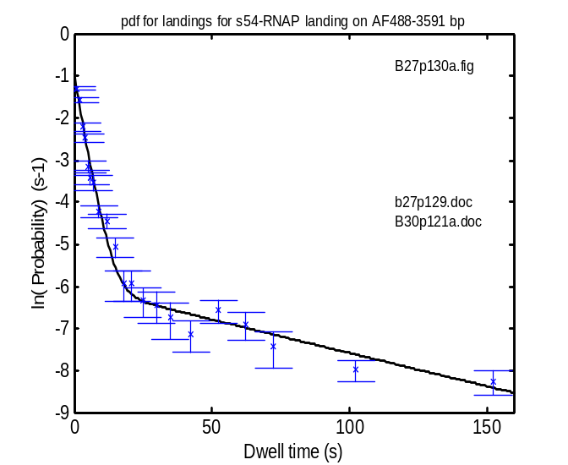
save P:\matlab12\larry\data\B30p121c.dat NbTb488 NbTbcntrl tym Widths N uncertN log_uncertN_norm_Lower log_uncertN_norm_Upper Edges Centers

% After cleaning up the figure in Powerpoint:
